**SHRI DATTA MEGHE POLYTECHNIC, NAGPUR**

**DEPARTMENT OF COMPUTER TECHNOLOGY**

**SESSION 2019-20**



Report of Micro Project for the subject Client Side Scripting Language (22519)

On

**TITLE OF PROJECT**

***Develop a JavaScript Framesets for Online E-Railway Ticketing System***

Submitted By

#### **1.Karan Kurani**

#### **2. Riddhi Hedaoo**

#### **3. Sahil Wadhigre**

Group No.1

Fifth Semester

COMPUTER TECHNOLOGY

*Guide*

Mr.G.Vaidhaya

**Title of the Project:** Develop a JavaScript Framesets for Online E-Railway Ticketing System

**Source Code:**

<html>

<head>

<title>RSK Trains</title>

</head>

<link rel ="stylesheet" type="text/css" href="inter.css">

<body bg background="carbg.png" text ="Black">

<nav>

<a href="homepage.html"><li>Home</li></a>

<a href="book.html"><li>Book</li></a>

<a href="food.html"><li>Food</li></a>

<a href="help.HTML"><li>Help</li></a>

<a href="exit.html"><li>Exit</li></a>

<form>

<br><br><br><br><br><br><br><br><br><br><br><br><br><br><br><br>&nbsp;&nbsp;&nbsp;&nbsp;&nbsp;&nbsp;&nbsp;&nbsp;&nbsp;&nbsp;&nbsp;&nbsp;&nbsp;&nbsp;&nbsp;&nbsp;&nbsp;&nbsp;&nbsp;&nbsp;&nbsp;&nbsp;&nbsp;&nbsp;&nbsp;&nbsp;&nbsp;&nbsp;&nbsp;&nbsp;&nbsp;&nbsp;&nbsp;&nbsp;<select>

<option>All Classes</option>

<option>Genral</option>

<option>Sleeper</option>

<option>AC-I-class</option>

<option>AC-II-class</option>

<option>AC-III-class</option>

</select>

&nbsp;&nbsp;

<select>

<option><h1>Berth Preference</h1></option>

<option>L/B</option>

<option>M/B</option>

<option>U/B</option>

<option>S/L/B</option>

<option>S/U/B</option>

</select>

<h5>&nbsp;&nbsp;&nbsp;&nbsp;&nbsp;&nbsp;&nbsp;&nbsp;&nbsp;&nbsp;&nbsp;&nbsp;&nbsp;&nbsp;&nbsp;&nbsp;&nbsp;&nbsp;&nbsp;&nbsp;&nbsp;&nbsp;&nbsp;&nbsp;&nbsp;&nbsp;&nbsp;&nbsp;&nbsp;&nbsp;&nbsp;&nbsp;&nbsp;&nbsp;&nbsp;&nbsp;&nbsp;&nbsp;&nbsp;

<input type="checkbox" name="fruit" value="Apple"><font face="Calibri">Flexible With Date<br>

&nbsp;&nbsp;&nbsp;&nbsp;&nbsp;&nbsp;&nbsp;&nbsp;&nbsp;&nbsp;&nbsp;&nbsp;&nbsp;&nbsp;&nbsp;&nbsp;&nbsp;&nbsp;&nbsp;&nbsp;&nbsp;&nbsp;&nbsp;&nbsp;&nbsp;&nbsp;&nbsp;&nbsp;&nbsp;&nbsp;&nbsp;&nbsp;&nbsp;&nbsp;&nbsp;&nbsp;&nbsp;&nbsp;&nbsp;&nbsp;&nbsp;&nbsp;&nbsp;

<input type="checkbox" name="fruit" value="Orange"><font face="Calibri">Divyang Concession<font face="Times New Roman"><input type="checkbox" name="fruit" value="Banana"><font face="Calibri">Journalist Concession

</6><br><br>

&nbsp;&nbsp;&nbsp;&nbsp;&nbsp;&nbsp;&nbsp;&nbsp;&nbsp;&nbsp;&nbsp;&nbsp;&nbsp;&nbsp;&nbsp;&nbsp;&nbsp;&nbsp;&nbsp;&nbsp;&nbsp;&nbsp;&nbsp;&nbsp;&nbsp;&nbsp;&nbsp;&nbsp;&nbsp;&nbsp;&nbsp;&nbsp;&nbsp;&nbsp;&nbsp;&nbsp;&nbsp;&nbsp;&nbsp;&nbsp;&nbsp;&nbsp;&nbsp;&nbsp;&nbsp;&nbsp;

<a href="phome.html"><img src =a.png></a><br><br>

&nbsp;&nbsp;&nbsp;&nbsp;&nbsp;&nbsp;&nbsp;&nbsp;&nbsp;&nbsp;&nbsp;&nbsp;&nbsp;&nbsp;&nbsp;&nbsp;&nbsp;&nbsp;&nbsp;&nbsp;&nbsp;&nbsp;&nbsp;&nbsp;&nbsp;&nbsp;&nbsp;&nbsp;&nbsp;&nbsp;&nbsp;&nbsp;&nbsp;&nbsp;&nbsp;&nbsp;&nbsp;&nbsp;&nbsp;&nbsp;&nbsp;&nbsp;&nbsp;&nbsp;<a href="phome.html"><img src =pnr.png></a>

<a href="phome.html"><img src =charts.png></a>

</html>

**Inter.css**

h1

{

color :black;

}

li

{

display:inline;

margin:20px;

}

**Output:**

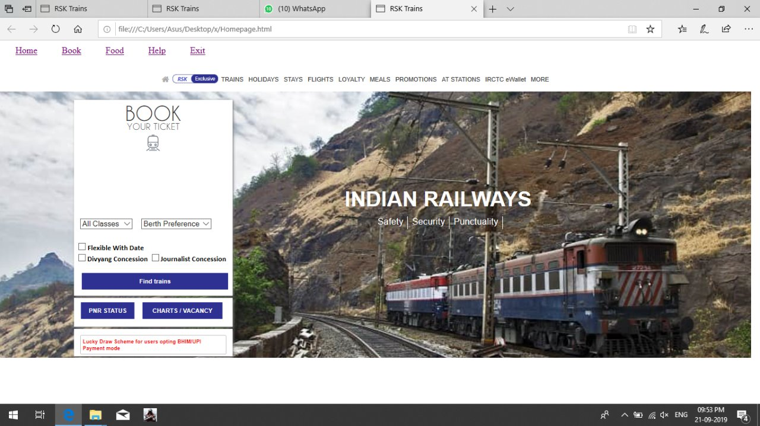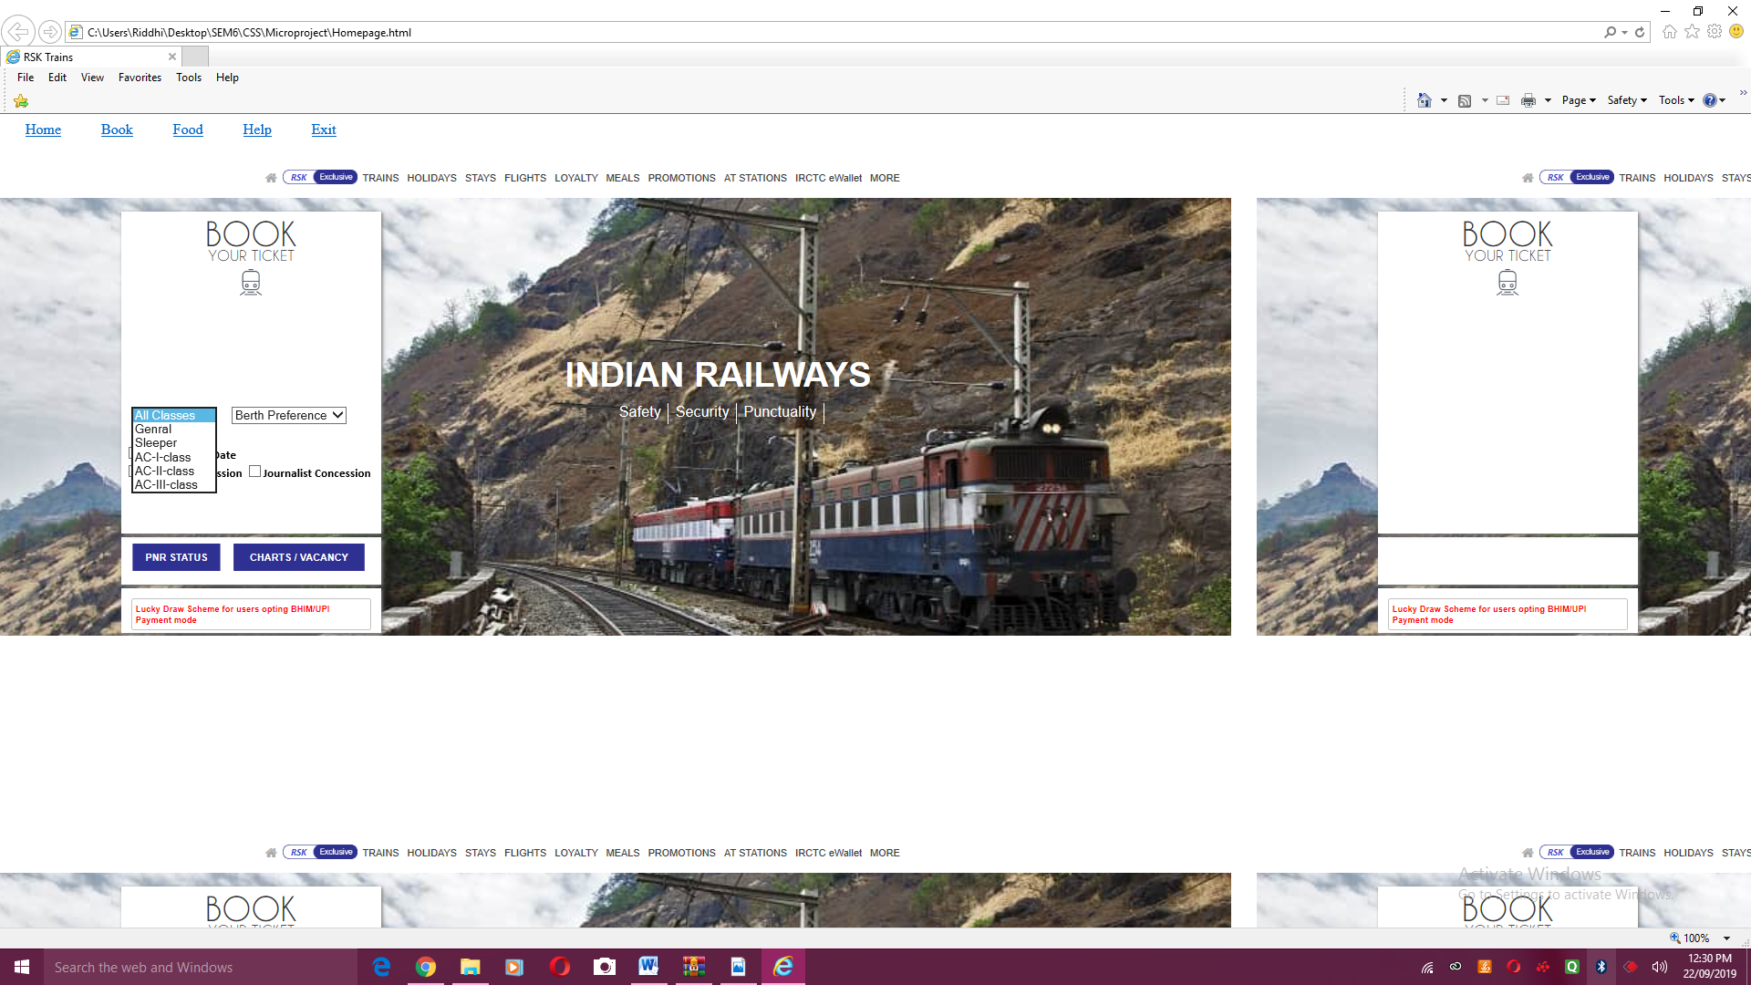

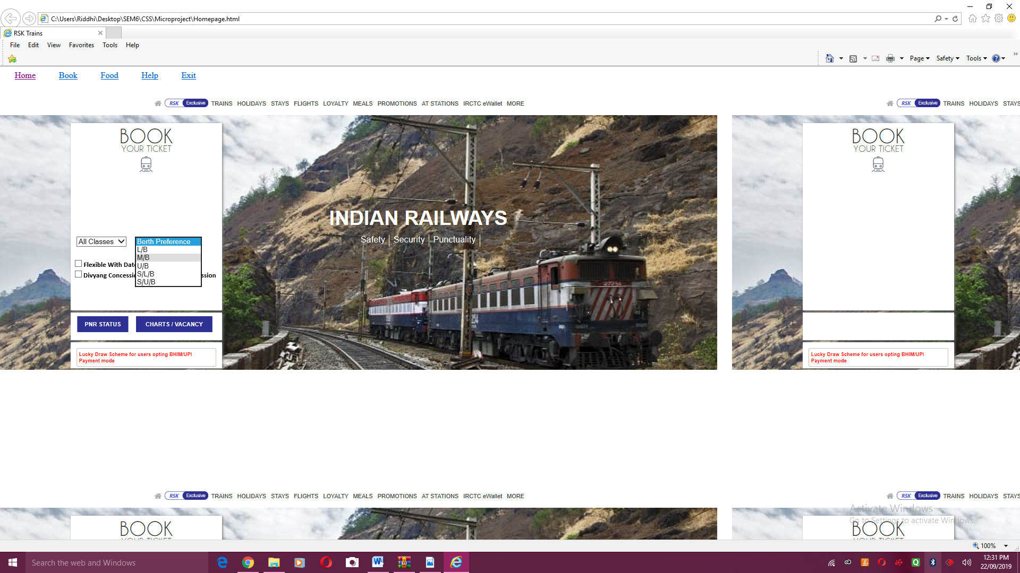 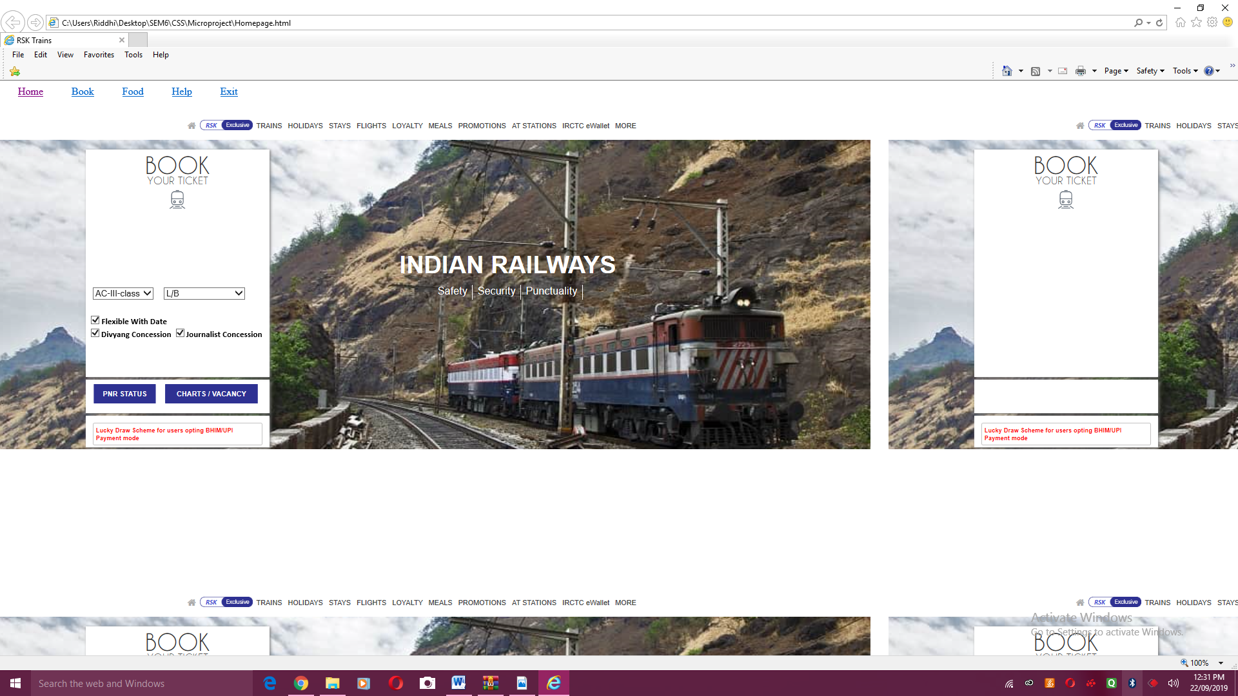

**References:**

<https://www.irctc.co.in/nget/train-search>